**Analysis of People Shot To Death by Police in the USA since 2015**

This data in this analysis was compiled using three different sources. The first is a Washington Post dataset of the number of people killed by the police in the USA since 2015, This data is available on Github at <https://github.com/washingtonpost/data-police-shootings>. The second is a listing of the police agencies involved in each shooting, available from the same Github link. The third is a dataset by Neilsberg Data of the United States Population by Race and Ethnicity. This dataset can be found at <https://www.neilsberg.com/insights/united-states-population-by-race/>.

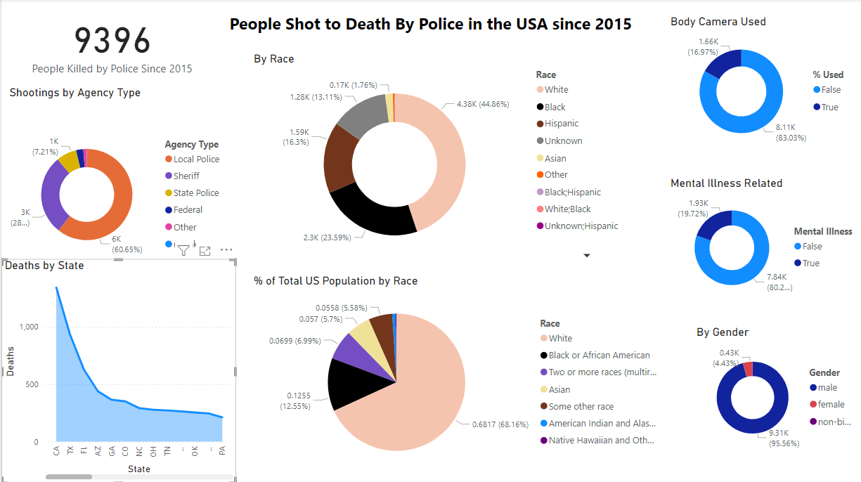

First, the figure of 9396 people killed by the police in the United States since 2015 is striking. That’s nearly ten thousand people. That’s like an entire World Trade Center collapse, only this happened over less than a decade.



Second, only 4.3% of the people shot by police were female. I do not believe that females are either more or less likely to be criminals, be violent, or have a mental health crisis than males.



Close to 20% of the shootings were related to mental illness, so nearly a fifth of the shooting deaths. Mentally ill people need mental health professionals. Police in the United States are not taught to be psychiatrists or psychologists.



Body cameras were used in only 16.97% of the fatal shootings by police. That seems like a very low percentage of the total shootings, especially since body cameras have been used for quite some time.

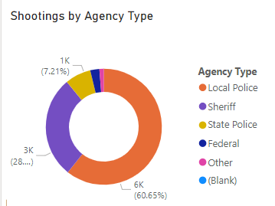

The local police were responsible for 60.65% of the fatal shootings. Sheriff, state police, federal, and other police agencies like campus police were responsible for the rest, so these shootings are much more likely to happen in urban areas.



The most striking data is about the racial makeup of the people killed by police. Race is a social construct relating to the level and hue of melanin in a person’s skin. Unfortunately, it does have a bearing on the data. Black people only make up 12.55% of the population, but 23% of the people killed by police were Black. White people make up 68.16% of the population, but 44.86% of the people in this dataset were white. Hispanic people make up 5.58% of the US population (“other” in the population dataset), but 16.3% of the people killed by police are Hispanic. Therefore, race does play a part in the number of police shootings.



The data on the shooting deaths of people by police by state is not initially surprising, because California, Texas, and Florida all have large populations and large urban areas. Arizona also has some large urban centers, and Georgia has Atlanta. However, New York isn’t even in the top ten, coming in at 15th, even though New York City is one of the most densely populated urban centers in the world, and is also an extremely diverse city.

**Conclusions**

These datasets bring forth some very troubling statistics. Race and gender play a part in police shootings. Sadly, so does having a mental health crisis. People in this situation need medication, hospitalization, and local services, not to be shot.

More data is needed, such as if drugs and alcohol played a part and what the policies are regarding shootings. Do these vary by locality or state?

The nearly ten thousand people who were killed by police since 2015 point to something being horribly wrong in the USA. The Washington Post is attempting to hold police departments in the USA accountable for the loss of life. The people shot never had their day in court, and therefore guilt or innocence of the people shot by police has not been established. Even if every single one of these nearly ten thousand people were guilty of committing a crime, it should not have been a death sentence.

Bodycams should be a part of every police uniform, at least when out on a call, and mentally ill people should get an evaluation by a mental health professional. These changes would cost time, money, and lots of work to implement, but the cost of not acting is in human lives.